
SPRING PROPOSAL

SAND SAMPLING APPARATUS
EGLIN AIR FORCE BASE
GROUP #4
RUBEN DE SOUSA
RICHARD KLIMAS
DANIEL MORTENSEN
GINA TEOFILAK

December 2, 2008

Abstract

The team has been working for one semester on a senior design project for the Mechanical Engineering department at Florida State University. The project is inspired to help improve an existing experiment at Eglin Air Force Research Laboratory. In the experiment a projectile is shot into a sand box and then samples of the sand are obtained and analyzed. Their current method sampling is lengthy and inaccurate. The objective of the project is to design the apparatus and method for obtaining accurate sand samples. The apparatus is an automated mechanism programmed to move the tip of a vacuum machine around the box creating the surfaces from where the samples need to be obtained. The actual samples will then be obtained by manually placing sampling tape on those surfaces. During the next semester the mechanism needs to be built and tested to prove its functionality. The tests should prove that the new method is simpler, faster, and can obtain more accurate samples than the previous method used in this experiment. The group will do several tests without shooting to determine the ideal speed for the movement of the mechanism and then run the experiment to prove the methodology.

Introduction

Warhead design engineers and material scientists require mechanical property information under high deformation rates of loading on a wide variety of materials that have military significance. Over the past decade, a new class of materials has begun to receive attention because it affects the performance of most all warhead designs. This new class is called "particulate materials" and includes a diverse collection of materials such as sand, explosive grains and potting materials. One technique used to probe the behavior of such materials is to fill a large "box" with sand and fire a hemispherical-nosed projectile into it (See Figure 1). The hemispherical nose provides a spectrum of loading conditions and the rapid projectile deceleration provides a velocity spectrum. During such events, the projectile disturbs and crushes the sand. It has been noted that the disturbed/crushed state of the sand correlates with the conditions that affected it. However, there is no good technique for extracting sand samples making so many measurements not very definitive or useful. The Damage Mechanisms Branch has a requirement to develop a new technique for extracting sand samples from the target.

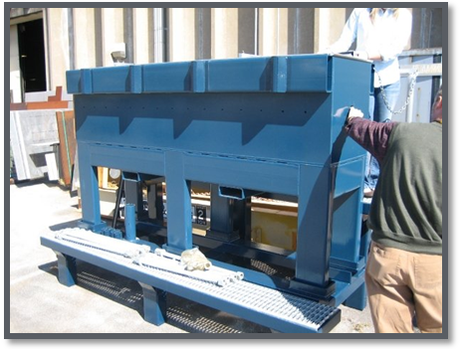
Figure 1. Picture of the “box”
It is common that engineering products undergo several sessions of tests before being implemented. In fact part of the objective of the Senior Design project is to allow students comprehend that theoretical values are often influenced by a number of assumptions. The testing part of a product development process can be exciting since it is the moment to realize the functionality of the product. This project is a clear example of this situation. This apparatus works in one of the stages of a larger research project. It is important to keep in mind that effective sampling of the sand results in good data to analyze. This design is ready to be verified as effective. Since this experiment started very recently the apparatus and method are expected to improve many aspects of the experiment. First, the sand must conserve its post impact position until it sticks to the sampling tape. It is also important that the exact location of the sample is recorded. Second, time is money. Technicians and engineers should not be wasting time scooping sand out of a box. The data analysis is the place where they should spend their time. Third, it most be practical. Data acquisition equipment in this experiment should have clear and simple instructions that do not need an expert to operate. The simplicity part includes having a consistent way of running the experiment. It should be easy to mount and dismount on a safe matter for each experiment. This experiment is so new that the procedure for each run is improvised. Fourth and last, it should flexibility to keep improving. Although the senior design project will fix many of the problems it should allow our sponsor to freely keep building on the apparatus. The group will suggest a few ideas that are possible improvements for the design, but that are not possible under our budget.

The question remains if the mechanism designed is delicate enough to allow the sampling throughout the box without disturbing the pattern created by the projectile, at the same time do it faster and more accurate than the previous methods. It must be tested on its versatility to withstand the environmental conditions and also allow for the technicians to use it without any training.

Description of the mechanism

The mechanism has three degrees of freedom meaning that it can linearly move in one vertical direction following the Z axis and two horizontal directions following X and Y axis (See Figure 2). The X axis is driven by a motor attached to a chain and sprocket assembly. The Y axis is driven by a motor at the end of a threaded rod. As this threaded rod moves it translates a plate that is rigidly attached to the Z actuator. The Z actuator is another motorized threaded rod that moves the vacuum tip in the vertical direction.

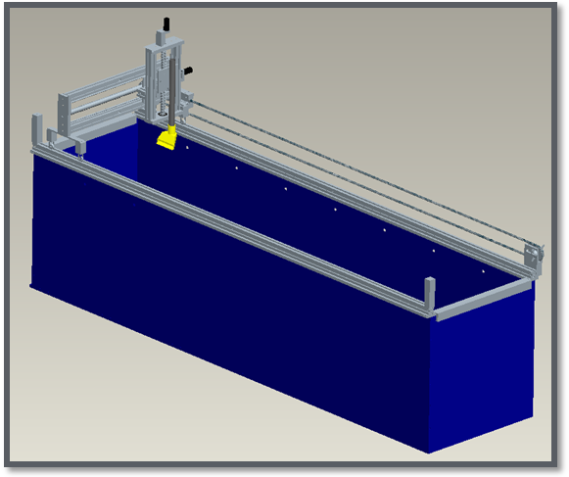
X
Y

Z
Figure 2. Mechanism mounted on top of the box.

The motors are wired through a control system and with a combination of encoders and switches the mechanism will follow a series of movements to remove an entire layer of sand. The depth of the layer will be variable depending on the number of samples wanted from a particular area of the box. Figure 3 shows a top view of the programmed sequence to take one layer of sand.
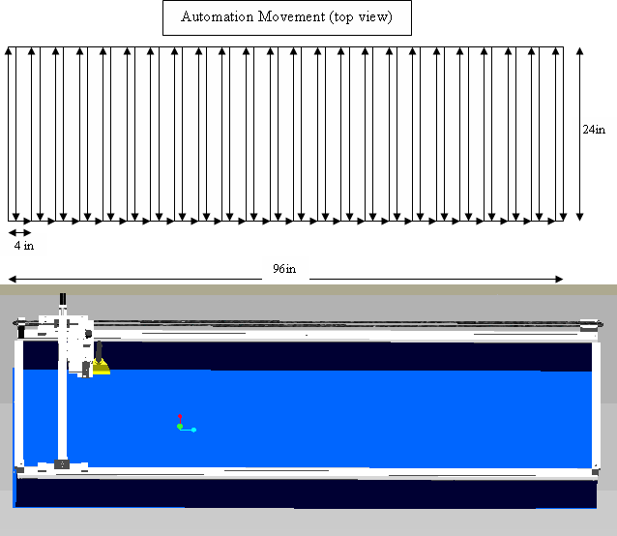
Figure 3. Top view of programmed motion for removing one layer of sand

The tip of the vacuum machine is four inches wide and has four pins equally spaced extruding from the bottom. These pins mark the sand with channels one inch apart. The markings facilitate straight placement of the sampling tape and provide the location in the X direction. Figure 4 shows an example of the expected method of getting the samples.

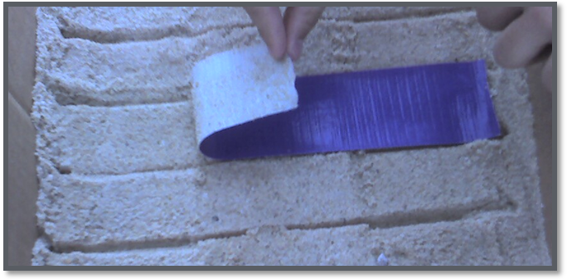
Figure 4. Example of the use of the tape to get samples

Approach/Method

By the beginning of the spring semester the mechanism will be assembled and programmed. A number of experiments will be set up to test all the points discussed earlier. The following are the minimum experiments that will be performed:

- Alignment test: The apparatus will be taken to Eglin facilities and mounted into the actual target to check for good fit and alignment.
- Handling Test: People of random sizes and technical background will lift and try to place the mechanism on its position. The statistics of this experiment will explore issues like safety and restrictions on the amount of personal or equipment that is needed for the installation of the mechanism.
- Program Test: The mechanism will be tested without sand to measure accuracy of the control system. The control system must follow the given action and display the coordinates. Accuracy of the coordinates and the maximum range in each direction will be tested.
- Speed Test: A relationship must be determined between the maximum allowable speeds for vacuuming versus the depth of the extraction. This test will set a goal for the total time of operation.
- Disturbance test: This experiment will test the pressures caused by the mechanism on the sand. This could be done with pressure sensors inside the sand.

Once all of these are done and our sponsor approves for scheduling an actual test the mechanism will undergo any modifications needed. This experiment is not conducted often. In fact it was not conducted at all in the previous four months, however we will push into trying the experiment as many times as possible to get substantial evidence that the method is effective. Another goal that the group is proposed to work on is to create a replacement tip that can also take samples of a small volume instead of this layers like the tape. This will be dependent on time and budget.

Fall 2008 Calendar
Semester 1 | Major Task
Week 01 | Get project assignments
Week 02 | Get project assignments
Week 03 | Team Building
Week 04 | Determine Needs Assessment and Scope  Meet the Sponsor and Faculty advisor
Week 05 | Research
Week 06 | Research
Week 07 | Concept Generation
Week 08 | Design Selection
Week 09 | Concept Development
Week 10 | Concept Development
Week 11 | Concept Development
Week 12 | Detail design analysis and modeling parts
Week 13 | Detail design analysis and modeling parts
Week 14 | Prepare Final package: Report, spring proposal, schedule and final presentation
Week 15
Week 16 | Finalize manufacturing drawings, schedule appointments in the machine shop, purchase parts and materials
Spring 2009 Calendar
Semester 2 | Major Task
Week 01 | Machine, assemble, and write the program
Week 02 | Set up appointments and write procedures for testing
Week 03 | Testing and modification, write procedures for running the experiment, conduct necessary surveys
Week 04
Week 05
Week 06
Week 07 | Conduct the experiment
Week 08 | Conduct the experiment
Week 09 | Conduct the experiment
Week 10 | Conduct the experiment
Week 11 | Conduct the experiment
Week 12 | Analyze the experiences of the experiments in order to set a general procedure for the experiment, write the operations manual.
Week 13
Week 14
Week 15
Week 16 | Prepare Final package: Report and final presentation

Cost Analysis

Table 1 displays information including the cost of individual parts or materials needed. These materials and parts are definitive. Most of them were chosen specifically to be easily replaceable. The group has access without charge to machine parts at the Air Force Research Laboratory’s machine shop as well as the one at Dynatech Associates. This is extremely convenient since Dynatech Associates can get free shipping from Alro Steel and during testing it will be helpful to be able to use Eglin’s equipment for minor modifications.

TABLE 1. Prices of parts and materials
Part | Part Number | Company | Price(USD) | Qty | Total(USD)
*ACME threaded rod | 98980A395 | McMaster | 157.00 | 1 | 157.00
*ACME Nut | 95365A526 | McMaster | 111.28 | 2 | 48.65
*Bearing (Ball) | 60355K48 | McMaster | 8.12 | 4 | 32.48
*Bearing (Open linear) | 5986K26 | McMaster | 23.47 | 3 | 70.41
*Bearing (Open linear) | 5986K2 | McMaster | 13.16 | 4 | 52.64
*Chain | 6261k21 | McMaster | 54.80 | 1 | 54.80
*Chain (Corrosion res.) | 7210k122 | McMaster | 95.00 | 1 | 95.00
*Sprocket | 6663k21 | McMaster | 19.09 | 3 | 57.27
80/ 20 extrusion |  | Alro Steel | 8.00 | 25 | 200.00
Aluminum |  | Alro Steel | 4.00 | 8 | 32.00
Aluminum |  | Alro Steel | 4.00 | 6 | 24.00
Steel rod |  | Alro Steel | 4.00 | 8 | 32.00
Track wheels |  | Alro Steel | 28.00 | 4 | 112.00
Aluminum |  | Alro Steel | 4.00 | 6 | 24.00
Steel rod |  | Alro Steel | 38.00 | 2 | 76.00
Miscellaneous hardware |  | Lowes | 23.97 | 1 | 23.97
*Switches |  | Robotstore | 1.59 | 2 | 3.18
*Power supply |  | Robot Market Place | 33.99 | 1 | 33.99
*Motors |  | Trossen Robotics | 38.70 | 3 | 116.10
*Encoders |  | Trossen Robotics | 38.00 | 2 | 76.00
*STAMP |  | Trossen Robotics | 124.50 | 1 | 124.50
*Motor Controllers |  | Trossen Robotics | 28.75 | 3 | 86.25
*Motor Bearing blocks |  | Trossen Robotics | 10.00 | 3 | 30.00
*Misc. wire |  | Trossen Robotics | 30.00 | 1 | 30.00
*Vacuum tip | uptool | Mid America Vacuum Center | 6.50 | 1 | 6.50
*This prices do not include shipping and handling cost

Due to concerns on going over budget the total cost was calculated using four different options. The first one is to use the current configuration using wheels on a track and a treated carbon steel chain for corrosion resistance. McMaster sales the same size of chain that is not very resistant to corrosion and using this chain, which is cheaper, would be the second option. The third and fourth options use the idea suggested that used supported rods and linear bearings for motion in the X direction. This might be a good idea as far as cost since the frictionless wheels and aluminum extrusion from the tracks would not be needed. Table 2 compares the total cost of the four options.

TABLE 2. Total cost excluding shipping cost
Option | Total (USD)
Wheels and corrosion res. chain | 1397.53
Wheels and non-corrosion res. chain | 1357.33
Rods and corrosion res. chain | 1291.94
Rods and non-corrosion res. chain | 1251.74

This proves that overall having the rods and open linear bearings for the motion on the X direction would not only be safer but also more economical than having the actuators resting on wheels.

